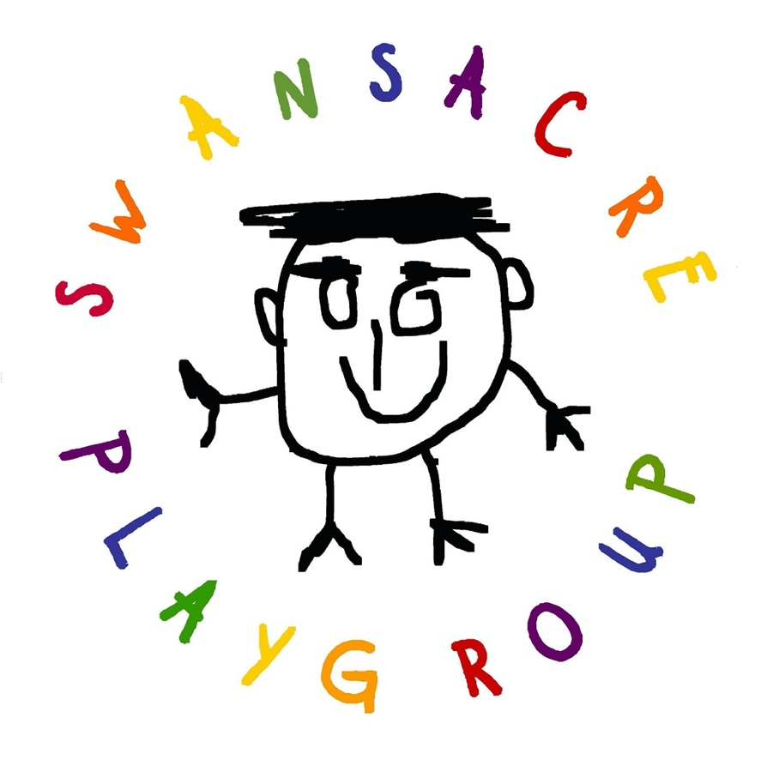

Swansacre Playgroup
Welcome Booklet

Swansacre Playgroup, 21 – 23 Swansacre, Kinross, KY13 8TE
Registered Scottish Charity SCIO SC017748

Version 2022

On behalf of Swansacre Playgroup, we would like to welcome you to our playgroup.

We have been providing Early Years Learning and Childcare to Kinross and the surrounding areas for over 50 years.
We offer an excellent range of sessions, for children aged 2 up to children in their pre-school year. Details of all our sessions can be found in this booklet.
We are a charitable organisation and have a committee of volunteer parents who help manage the playgroup alongside Natalie, our manager and the wonderful team of Early Years Practitioners who is made up of Ali, Faye, Debbie, Jaime-Lee and Lisa.
We also have a lovely team of volunteers, who are PVG checked, and help out during our sessions.
You will find pictures of all our staff, volunteers and committee members as you enter the playgroup.
If you would like to contact Swansacre Playgroup, please call 01577 862071 or 07592392235. If you would like to enrol your child(ren) in one or more of our sessions, please contact our Enrolments on enrolments.swansacre@gmail.com
We hope you and your family enjoy your time with Swansacre Playgroup.

Aims and Objectives
Swansacre Playgroup aims to support and enhance the education of children from the age of 2 until they start school.
Our sessions are tailored around the little people who we are there to support and give them the very best early years education and childcare possible.

We operate under the legal control of The Care Inspectorate and are inspected regularly. This includes observing our governing document, ‘How Good is Our Early Learning and Childcare’ (HGIOELC), ‘Setting the Table’ and ‘Getting it Right for Every Child’ (GIRFEC) and Realising the Ambition and Pre-Birth to 3.

Our primary objective is to provide a safe, welcoming, secure, stimulating, nurturing and, above all, fun environment where pre-school children can learn and develop through play.
Children can participate in free play through choosing the activities they want to get involved in themselves and whether they would like to play indoors or outdoors. At the centre of all that we do at Swansacre Playgroup is our children and their health and wellbeing. We are there to support, encourage, and expand their imaginations.

Swansacre Playgroup Sessions______________________________________________

We are open 9am – 3pm, with the options of doing just morning, afternoon or a full day. We recently became a 1140 funded provider so we can offer lunches and if you do not currently access this, we can also provide lunch for an additional cost of £2.80

Our session aims to fully embrace the vast learning experience of the outdoor environment.
Research has shown the extensive benefits of outdoor, nature-based play for young children; we aim to be outside for the whole session, regardless of the weather, so suitable clothing will be required! However, we can (and will) utilise the building if necessary!!

The group is a member of Early Years Scotland and looks to advance the education of pre-school children so that they may take a constructive place in the community. We operate under the legal control of The Care Inspectorate and are inspected regularly.
Our primary objective is to provide a safe, secure, interesting, stimulating, nurturing and above all, fun environment where all children can learn and develop through play.
Children are encouraged to participate in free play, choosing the activities they want to get involved in themselves although the sessions have some structure: children group together for a discussion relating to the current topic for activities, and for a healthy snack and lunches. Children are also encouraged to participate in a craft activities and other activities throughout the session in small groups while being guided by our practitioners

Fees

Our fees are agreed annually at our AGM and voted for by our committee and any other parents/carers attending the AGM.
We have a Fee Policy which you will be required to read and sign prior to your child starting at Swansacre Playgroup. Should you wish to remove your child from Swansacre Playgroup a two-week notice period is required, and fees will be due for these two weeks even if your child does not attend Swansacre.
Fees are invoiced at the beginning of each term, and you will be emailed an invoice for your child’s sessions. Payment can either be in one payment or two instalments over the term.
Our preferred method of payment is a BACS transfer and we do accept various childcare vouchers. Fees queries can be sent to fees.swansacre@gmail.com

Waiting List

Swansacre Playgroup is extremely popular and currently run a waiting list. You will be notified if there is places available when applying and if there is not any spaces you can then be placed on the waiting list.

If your child already currently attends Swansacre Playgroup and you would like to request extra session(s), please email enrolements.swansacre@gmail.com who will advise you of availability and ask you to put your request in writing, an email will suffice. Children currently attending Swansacre are given priority over new children starting at the playgroup.

If you are new to Swansacre Playgroup, you will need to complete and return an enrolment form which will be retained until such times you child is either old enough to attend your chosen session or space within your chosen session become available.

A vacant space in sessions is allocated to child(ren) on the waiting list in the following order:

- The first child on the list who is a priorty with their requested session/day.

- The first child on the list who is age 2 or over with the relevant day requested or no day specified.

Parents/Carers can contact the enrolment officer, to request information regarding their child and their position on the list. This can be done by emailing enrolements.swansacre@gmail.com

Suitable Clothes

Our Outdoor Policy states that children will be encouraged to spend time playing outside at each session, depending on the weather. Children will be taken outside in wet, cold, and snowy weather as well as in hot weather unless it is extreme or poses a danger to the health and wellbeing of the children.

Please ensure that your child is appropriately dressed in suitable clothing, headgear, and footwear.
We ask parents to supply a selection of clothes for children to change into if they become wet through water play or weather.

We ask you in the wetter months to send your child in wearing their waterproofs.

We ask that during the spring and summer months you apply sunscreen to your child prior to coming to playgroup and provide a sunhat and long-sleeved top in their bag.

We do not have spare clothes so please make sure you send enough for the session.

Toileting and Nappy Changing

In line with our Child Protection Policy and our Toileting and Nappy Changing Policy all toileting and nappy changing will ONLY be dealt with by our staff. Volunteers will not take children to the toilet or change nappies however they may assist with hand washing prior to and after toileting if required.

We ask all new families to complete a toileting form when starting at Swansacre Playgroup, this helps the staff ensure that all the children feel safe and secure when using the bathroom facilities.

You will be asked to review this form every 6 months to ensure that we have the most up to date information regarding your child and their toileting.

If your child is toilet training, please do let us know and we can work with you and support your child in whatever way you feel appropriate in order to make the transition from nappies to pants as stress free as possible.

In case of any accidents, please supply some spare clothes in a bag with your child’s name on.

Staff Ratios

Swansacre Playgroup must abide by Scottish Government guidance on adult to children ratios.

In our setting our ratios are:

Age 2-3 1 adult : 5 Children
Age 3 and above 1 adult : 8 Children

Our sessions are run by qualified Early Years Practitioners that are SSSC registered, and First Aid trained with full PVG, they are supported by our volunteers. All our volunteers are Protection of Vulnerable Groups (PVG) checked and they also must complete a small application form and provide references.
If you would like to join our volunteer team, please speak to a member of staff who would be happy to help.
We have a cleaner who comes in every night to clean after our messy days and makes the setting all clean for us coming in the following day. Since Covid-19 all our staff and volunteers clean after the end of the session cleaning all toys and equipment but also throughout the day cleaning our touchpoints.

Swansacre Policies and Procedures

Swansacre Playgroup is governed by The Care Inspectorate and we operate according to all current Early Years Learning and Childcare Policies and Procedures by legal requirement.
Below is a summary of a number of our policies and procedures but please do ask our staff or a committee member if you would like to read or have a copy of one or more of these policies.

Settling In

Settling in is an important stage in the transition between home and Swansacre Playgroup, or between another setting and ours. We offer a welcoming environment, the children are encourage to wash their hands when they come in and then go and play. However if your child is not settling we would advise you to stay until they do.

We will aim to make this a smooth transition by:

- Giving the child and their parent/carer time to familiarise themselves with the playgroup environment.

- Offering a warm and welcoming environment and ensuring each child feels included, secure and valued. This is in line with the Health and Social Care Standards: 1.9,1.10,1.11

- Recognising each child as an individual and his or her readiness to leave the parent or carer and adapt to the new environment. This is in line with GIRFEC

- Sensitively dealing with the parent’s or carer’s readiness to leave their child.

- Providing strategies to help parents or carers to work with staff during the settling in period. The Scottish Schools (Parental Involvement) Act (2006) identifies the key role parents and carers play in a child’s life and highlights the importance of parents and carers and staff working together.

- Staggering intake of new children into the setting, if they require.

- Providing familiar play and learning activities and experiences. No child will be taken on an outing or visit until they are settled.

- Providing feedback to parents or carers about how their child is progressing and supporting them in the settling in process.

If your child does not settle and is unhappy and distressed at being at Swansacre Playgroup, a member of staff will contact you immediately and you will be more than welcome to come back to the playgroup to either stay with your child for the session, or settle them, or take your child home.
The team at Swansacre Playgroup will discuss with you the best way forward for your child and your family. This is in line with the Health and Social Care Standards, at points 3.1 and 3.4, - 3.13

Transition

As an Early Learning and Childcare (ELC) setting we recognise the importance of supporting toddlers and young children through the transition process. Transitions will be handled sensitively and will be a positive experience for both your child and your family.

Effective transition involves partnership working, effective communication and the tracking and recording of children’s progress. Transition arrangements will be planned and managed to support your child and family through the process.

Supported Transitions

Children will experience transitions at different times in their life and Swansacre Playgroup will support children to make successful and effective transitions. Transitions can be from home to school, within the setting, split placements (including childminders) and onward to primary school.

Children will be encouraged to develop a positive attitude to change and to develop new and secure relationships. Processes will be in place to record all aspects of children’s learning and achievements and this information will be shared with relevant colleagues and families to ensure continuity of learning.

Key Transitions

As an ELC we recognise the following points of transition as key stages in a child's emotional and learning journey and will plan carefully to support both the child and their family as they make these transitions.

Home to Setting

We respect and value all parents' knowledge of their child.

We will engage with you prior to your child joining us at Swansacre Playgroup, to gain as much knowledge of your child as possible, including care needs, preferences and developmental stage.

We will also explore any concerns you may have about starting their child at playgroup.

We always endeavour to build positive and relaxed relationships with all parents and carers which helps foster openness and trust.

A visit will be arranged for you and your child to Swansacre Playgroup, prior to them starting with us, where they can meet and get to know the staff team, form secure attachments and become familiar with the playgroup setting.

We know that starting playgroup can be a big step for both your child and you and we are sensitive to your child's readiness to join us, but also being parted from you, and your own needs and emotions.

Swansacre Playgroup offers support to both you and your child to help facilitate this transition.

Setting to Primary School

As a setting we foster positive collaborative working strategies with our local primary schools.

Where possible we will ensure that children have opportunities throughout their pre-school year to visit and participate in events in their receiving primary school in order to support them emotionally during transition and to promote a confident and successful move to primary school.

We will work closely with the schools and pass on any relevant information to help make the transitions go smoothly.

We acknowledge that not all of our children will move on to primary school within the cluster of our setting. This presents a greater challenge for collaboration, but we will endeavour to ensure that every child has a positive transition experience and that the receiving primary school is fully informed of the child's progress to date and has all relevant information regarding the child.

As in our practice with shared settings, we will meet with colleagues from local primary schools, where possible, to develop a shared understanding of progress and play-based pedagogy across the early level. We will seek objective evaluations from parents, children and partners to enable us to develop and improve the transition arrangements and programmes into primary school that we provide.

Toys

We would prefer parents and carers to discourage children from bringing their own toys into our premises as it is hard to keep track of these, but also other children may want to play with them. The exception to this is any item, blanket, or toy that is a comforter for your child. Please speak to a member of staff to advise how the comforter is used by your child.
We cannot be responsible for any toys that get damaged or broken.

Promoting Positive Behaviour

When a child is displaying challenging behaviour, this can be seen as a form of communication, but it can have an impact on staff, volunteers and other children.

Swansacre Playgroup will make every effort to work with parents in assessing and managing challenging behaviour. Our staff will inform you of any concerns they may feel need addressing and will work with you as detailed in our Promoting Positive Behaviour Policy.

Swansacre Playgroup will never use excessive force or restrain your child but if your child is causing a danger to themselves or others, they will be removed from the situation and taken to a quieter area with a member of staff who will remain with them. A member of the team will contact you immediately to inform you of the situation.

Additional Support Needs Statement

Children with additional support needs will never be excluded from Swansacre Playgroup. Please contact staff if you require any further information regarding a child with additional support needs.

Food Policy – Snacks & Lunch

Swansacre offers a healthy snack each day and offer lunch at an additional cost unless your child is eligible for 1140 funding, where they will get a free lunch. Our menu is displayed within the playgroup it is posted on our closed facebook page.

If your child has any food allergies or intolerances, please advise staff immediately and see the section below on Medication.

Please also read our Healthy Eating Policy for more details regarding our snacks.

During Lunch time, we promote healthy eating, so we ask that you do not send fizzy drinks or excessive amounts of sweets.
We encourage children to attempt to eat their packed lunch contents, so please think of how much your child is likely to eat!
We also ask that you do not include any ​nuts​ (or items​ containing nuts​) within the lunch boxes.

Medication Policy

Swansacre Playgroup has an ‘Administration of Medication’ policy which we ask you to read and sign if your child has a medical condition which will require our staff to administer either one off or regular medication. You will be asked to provide the medication sealed in its original packaging with a pharmacy label with your child’s name on it. The medication will be kept in our secure medicine cupboard or in the fridge if required. Our team will guide you through the documentation and procedures prior to your child beginning at playgroup to ensure safety for both your child and our staff.
Swansacre Playgroup does not routinely keep Calpol/Paracetamol for children. If you wish us to administer Calpol/Paracetamol to your children, we kindly ask that you supply us with a small amount of Calpol/Paracetamol and either a measuring spoon or syringe clearly labelled with your child’s name on it.

Illness & Absence

Swansacre Playgroup cannot accept any child who is had vomiting and/or diarrhoea unless 48 hours has passed since the last episode.

We cannot except children if they should be isolating or have a high temperature or any other symptoms of Covid-19.

If you are concerned about the health of your child, please discuss your concerns with a member of the team prior to leaving your child at Swansacre Playgroup.

We have a Communicable Diseases fact sheet displayed within the playgroup which can be used to assess if your child is able to attend their session. If you are unsure, please phone the playgroup prior to leaving your house and we can answer any questions you may have.

If your child becomes unwell during their session, we will contact you immediately for you, or if you do not answer your emergency contact, to come and collect your child.

We kindly ask that if your child is unwell and will not be attending their session that you inform the playgroup as soon as you are able. You can do this by texting the playgroup mobile phone which is checked each morning prior to sessions commencing.
If your child attends any other day care settings, please tell us.
• If your child is ill, they must not attend childcare
• If your child becomes unwell whilst in our care, we will phone you to agree a time for you to collect them
• Please tell us if your child has been ill while they are away from day care
• If your child has had symptoms of vomiting or diarrhoea (or both), it is essential that they do not attend day care until 48 hours after the symptoms have stopped
• If you’re not sure, please phone us before you bring your child to day care.
Immunisation
As your child will now be mixing with other children, it is important that they are protected and up to date with their immunisations. You can access further information about the immunisation schedule at http://www.immunisationscotland.org.uk
If you think your child has missed any vaccinations, please contact your general practice to arrange an appointment. You can also ask your health visitor for advice.

Non - Attendance of Children
________________________________________________________________
You will be advised when your child starts at Swansacre Playgroup that you should inform us of non-attendance of your child wherever possible.

it is your responsibility to ensure that all contact details are up to date.

Our enrolment forms ask, where possible, for you to provide 3 contact numbers. These should be the primary Parent/Carer and/or secondary Parent/Carer (such as mother and father) and the third should be an emergency contact, with whom Swansacre can speak to in the event of an emergency.
We will only call them if there is no answer from the primary and/or secondary parent/carer numbers.

In the event that your child does not arrive at playgroup when they are expected for a session, the following procedure will automatically take place:

1. When a child was expected to attend and doesn’t, and where no notice of absence has been received, Swansacre staff will contact parents/carers as soon as reasonably possible, to establish that the child is safe, the reason for their absence and the likely period of absence.

2. Where direct contact cannot be made, a voice message will be left with the parent/carer stating the reason for the call and we will ask you to return the call to us or to text the Swansacre mobile saying why the child was absent.

We will keep a record details of the call, date, time, who called you, on our daily register in the Absence Section.

When the parent/carer returns the call, the reason for the absence should be written in the Absence Section beside the previous note.

3. If there is no contact from the parent/carer the following day, Swansacre Playgroup manager must be informed, and a follow-up call will be made to the parent/carer and also any other contacts on the child’s record. (Again, this will all be recorded in the Absence Section with the same details as above.)

It is likely that contact will be made with someone at this point. If contact cannot be made to explain the absence within a few days, then other (parent) members of playgroup should be asked if they have any information regarding the child/family (e.g. they may know that the family is on holiday).

Staff will use their own professional judgement, involve the Chairperson and if it is felt absolutely necessary, the matter will be referred to Social Services or the Police.

If deemed unnecessary to contact Social Services or the Police, the reasons will be documented by Swansacre Playgroup Manager.

4. For prolonged absences, staff will use their own professional judgement, based on particular situations and circumstances, as to how often to make check-up calls.

As a guide, Early Years Scotland recommends that this should be done at least on a weekly basis. If they are concerned about unexplained absences, Swansacre staff and Chairperson will refer the matter to Social Services or the Police.

Child Protection

Swansacre Playgroup is inspected by The Care Inspectorate who ensures that we operate in line with our Child Protection Policy.

We also operate within the Perth and Kinross Child Protection guidelines.

Our named Child Protection Officer is the manager and ECP Faye Nicolson who will be informed if there is a suspicion of child neglect, etc.

Swansacre Playgroup manager has the right to inform the area child protection team in any event concerning a child attending Swansacre Playgroup without consulting the parent/carer.

Collection of Children

Please inform staff when you drop your child off at playgroup if someone else is going to collect them.

You will need to give details of the nominated person and sign our Alternative Collection Log, as will the nominated person on their arrival.

If you do not inform staff your child may not be released to the nominated person.

Fire

In the event of a fire at Swansacre all children will be taken to Kinross Day Care Centre, High Street, Kinross and all parents/carers will be contacted and asked to collect their child from this location as soon as possible.
Please review our Fire Safety Document.
Emergency Closure

Snow and Ice Storms
In the event of severe weather, Swansacre Playgroup will monitor winter storm watch warnings, blizzard warnings or travel advice.

We will consider pre-storm closing (night before) or early closing depending on conditions. If local schools close early we will endeavour to close also and will contact parents immediately once the decision to close has been made.

If during the session we have no information about local schools but feel it safest to close the playgroup, a member of the team will contact all the parents of the children attending that session and advise that the manager and chairperson have taken the decision to close the playgroup.

Should we become aware the night prior to a session that the local schools will be closed the following day, we will contact all parents of the children who would be attending that session that the playgroup will be closed due to severe weather.

Further information can be found on PKC website regarding school closures but in general if Kinross Primary School is closed, Swansacre Playgroup will be closed also.

Flooding
- Swansacre Playgroup will monitor announcements of flood watch or warning and heed any evacuation orders from emergency safety officials.

- Close or evacuate the playgroup if needed.

Utility Disruption (gas, electricity, water)

If utilities are disrupted at Swansacre Playgroup, we will make every effort to remain open. The decision to close or delay opening will be based on the following factors:
- The amount of natural light in the playgroup

- The temperature in the playgroup.

- The risk to the health and well-being of children and staff.

The staff will begin calling parents/carers to inform them of the situation after 1 hour of disrupted service.

This time period will allow Swansacre Playgroup manager to assess the situation and provide families with as much accurate information as is available.

Swansacre Playgroup may close or delay opening (confirm with the management committee/manager) if the following conditions are present:
- The temperature on the centre thermometers registers 16° or below for one hour, with no expectation of heat/air conditioning restoration within the next one to two hours, and/or the room conditions prevent adequate ventilation and breathing.

- The natural light in the centre is diminished to the point that children and staff are at risk.

- The main phone line will be inoperable for more than one hour, and no mobile phones are available.

- The nutritional needs of the children cannot be met.

- Live wires will require the immediate closing of the building and the transfer of the children.

- Loss of water that disrupts nappy changing, hand washing, and toileting with clean running water for more than 1 hour, unless bottled water is available.

- In the event of a gas leak the playgroup will close immediately and if a leak is discovered during a session then emergency evacuation will be carried out and all parents and carers informed.

Working in Partnership with Parents

Swansacre Playgroup is run by a committee of parents and carers who are responsible for supporting the manager and ensuring the smooth operation of the playgroup.

Please speak to a member of staff if you feel you would be able to help the committee in any way or if you would like to take on a specific role within the committee.

As a children’s charity we rely heavily on fundraising to help with the running costs of the playgroup. We are always looking for our parents to help with fundraising events and any home baking if we have an event on.

Photographs and the Internet

Parents are asked to give permission for photographs to be taken of their child and also for these to be displayed in Swansacre and on our website.

Permission is also required for the use and distribution (to other parents) of photographs where your child is in the background.

This information will be given at registration and then reviewed every 6 months thereafter. Should you change your mind and wish to alter your permissions, please feel free to speak to a member of the team who will be more than happy to help you.

Neighbours

Swansacre shares an access point with neighbours and rely on our members being considerate when dropping off and collecting children.

Please respect our neighbours – we kindly ask that you do not park across their garage. Please leave any buggies and/or bikes against the wall of Swansacre Playgroup building and not our neighbours’ wall.
We kindly as that you do not smoke or drop cigarette ends or litter in the vicinity of Swansacre.

Thank you.

Complaints Policy

Complaints can be made to a member of staff, committee, or our Lead Practitioner in the first instance. Every complaint will be taken seriously and dealt with in the strictest of confidence. However, as detailed in our Complaints Policy displayed on our Policy Noticeboard, parents and carers can contact The Care Inspectorate directly at the following address to report any complaints without first informing Swansacre Playgroup:
Compass House
11 Riverside Drive
Dundee
DD1 4NY
01382 207100
Complaints 0845 6030890

Please read the Complaints Procedure displayed on our noticeboard for further information.

